MY PBL- RULE OF THIRDS
My PBL is The Rule of Thirds. The rule of thirds is a vital technique of photography. It can be applied to any photo to improve the quality. You should think of the rule of thirds as a recommendation rather than a requirement. However, in most cases it produces a balanced and appealing photo and is a good starting point for any piece of work.
What is the Rule of Thirds?
The rule of thirds involves mentally dividing up your image using 2 horizontal lines and 2 vertical lines, as shown below. You then position the important elements in your scene along those lines, or at the points where they meet.
Rule of Thirds  The basic principle behind the rule of thirds is to imagine breaking an image down into thirds (both horizontally and vertically) so that you have 9 parts. | This picture falls on the intersection of the line on the  grid.  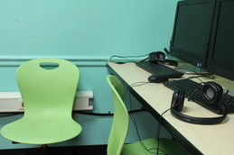
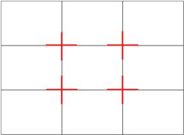 | Imagine the grid above over the picture.  This picture follows the rule of thirds.  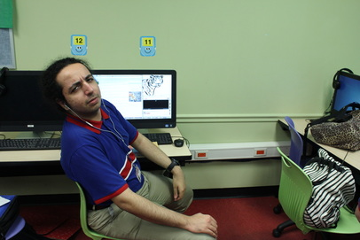
These pictures falls on the in the grids. | 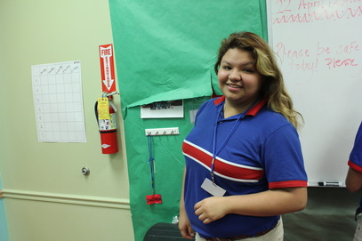
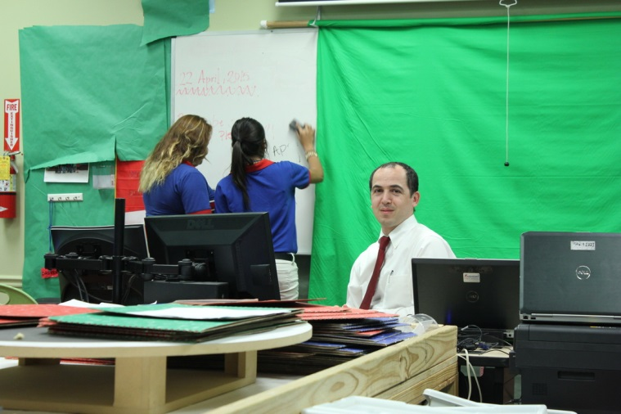 | 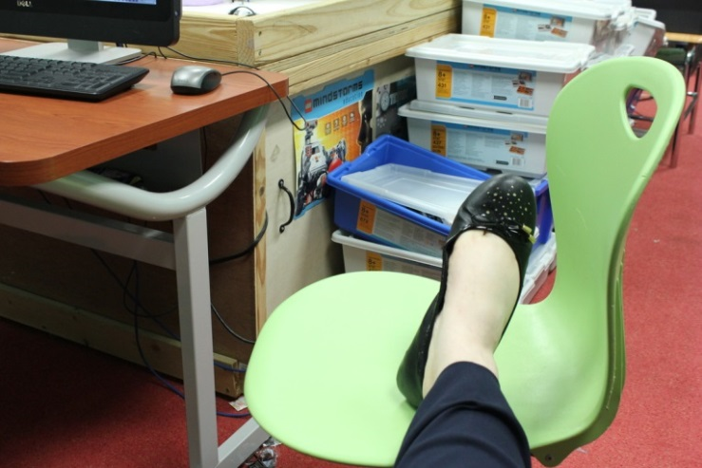

My Video | My Web

